Software Engineering Methods Coursework

Part 2

# UML Class diagram

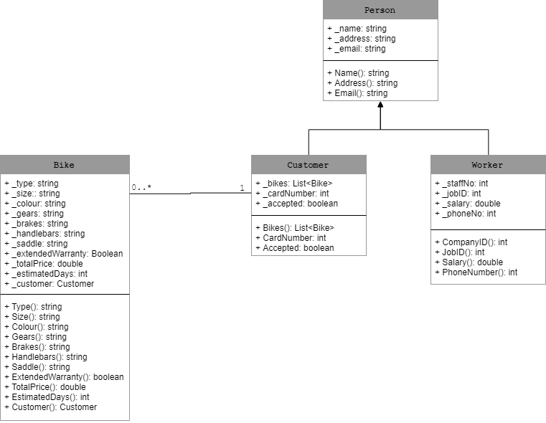

# Implementation and test units

## Classes:

|  |
| --- |
| namespace SEM_cw2  {  public class Person  {  private string _name;  private string _address;  private string _email;  public string Name  {  get { return _name; }  set { _name = value; }  }  public string Address  {  get { return _address; }  set { _address = value; }  }  public string Email  {  get { return _address; }  set { _address = value; }  }  }  } |
| using System;  using System.Collections.Generic;  namespace SEM_cw2  {  public class Customer : Person  {  private List<Bike> _bikes;  private int _cardNumber;  private Boolean _accepted;    public List<Bike> Bikes  {  get { return _bikes; }  set { _bikes = value; }  }  public int CardNumber  {  get { return _cardNumber; }  set { _cardNumber = value; }  }  public Boolean Accepted  {  get { return _accepted; }  set { _accepted = value; }  }    }  } |
| namespace SEM_cw2  {  public class Worker : Person  {  private int _staffNo;  private int _jobID;  private double _salary;  private int _phoneNo;  public int StaffNumber  {  get { return _staffNo; }  set { _staffNo = value; }  }  public int JobID  {  get { return _jobID; }  set { _jobID = value; }  }  public double Salary  {  get { return _salary; }  set { _salary = value; }  }  public int PhoneNumber  {  get { return _phoneNo; }  set { _phoneNo = value; }  }    }  } |
| using System;  namespace SEM_cw2  {  public class Bike  {  private int _id;  private string _type;  private string _wheels;  private string _size;  private string _colour;  private string _gears;  private string _brakes;  private string _handlebars;  private string _saddle;  private Boolean _extendedWarranty;  private double _totalPrice;  private double _estimatedDays;  private Customer _customer;  public int ID  {  get { return _id; }  set { _id = value; }  }  public string Type  {  get { return _type; }  set  {  if (value == "mountain" || value == "road")  {  _type = value;  }  else  throw new ArgumentException("type is wrong");  }  }  public string Wheels  {  get { return _wheels; }  set  {  if (value == "small" || value == "large")  {  _wheels = value;  }  else  throw new ArgumentException("wheel is wrong");  }  }  public string Size  {  get { return _size; }  set  {  if (value == "small" || value == "medium" || value == "large")  {  _size = value;  }  else  throw new ArgumentException("type is wrong");  }  }  public string Colour  {  get { return _colour; }  set { _colour = value; }  }  public string Gears  {  get { return _gears; }  set  {  if (value == "Type A" || value == "Type B")  {  _gears = value;  }  else  throw new ArgumentException("gear is wrong");  }  }  public string Brakes  {  get { return _brakes; }  set  {  if (value == "Type A" || value == "Type B")  {  _brakes = value;  }  else  throw new ArgumentException("brakes is wrong");  }  }  public string Handlebars  {  get { return _handlebars; }  set  {  if (value == "Type A" || value == "Type B")  {  _handlebars = value;  }  else  throw new ArgumentException("handlebars are wrong");  }  }  public string Saddle  {  get { return _saddle; }  set  {  if (value == "Type A" || value == "Type B")  {  _saddle = value;  }  else  throw new ArgumentException("saddle is wrong");  }  }  public Boolean ExtendedWarranty  {  get { return _extendedWarranty; }  set { _extendedWarranty = value; }  }  public double TotalPrice  {  get { return _totalPrice; }  set { _totalPrice = value; }  }  public double EstimatedDays  {  get { return _estimatedDays; }  set { _estimatedDays = value; }  }  public Customer Customer  {  get { return _customer; }  set { _customer = value; }  }  }  } |

## Test unit for Bike class:

|  |
| --- |
| using System;  using Microsoft.VisualStudio.TestTools.UnitTesting;  using SEM_cw2;  namespace TestingClasses  {  [TestClass]  public class UnitTest1  {  //the bike object to test  Bike bike = new Bike();    [TestMethod]  [ExpectedException(typeof(ArgumentException))]  public void typeTest()  {  bike.Type = "hi";  }  [TestMethod]  public void typeTest2()  {  bike.Type = "small";  }  [TestMethod]  [ExpectedException(typeof(ArgumentException))]  public void wheelTest()  {  bike.Wheels = "asdasd";  }  [TestMethod]  [ExpectedException(typeof(ArgumentException))]  public void sizeTest()  {  bike.Wheels = "asdsad";  }  }  } |

# User Interface

